*Salutations CS501 Dudes, and Dudettes!* My name is Ryan Skelly, and I will be your Discussion Leader on:

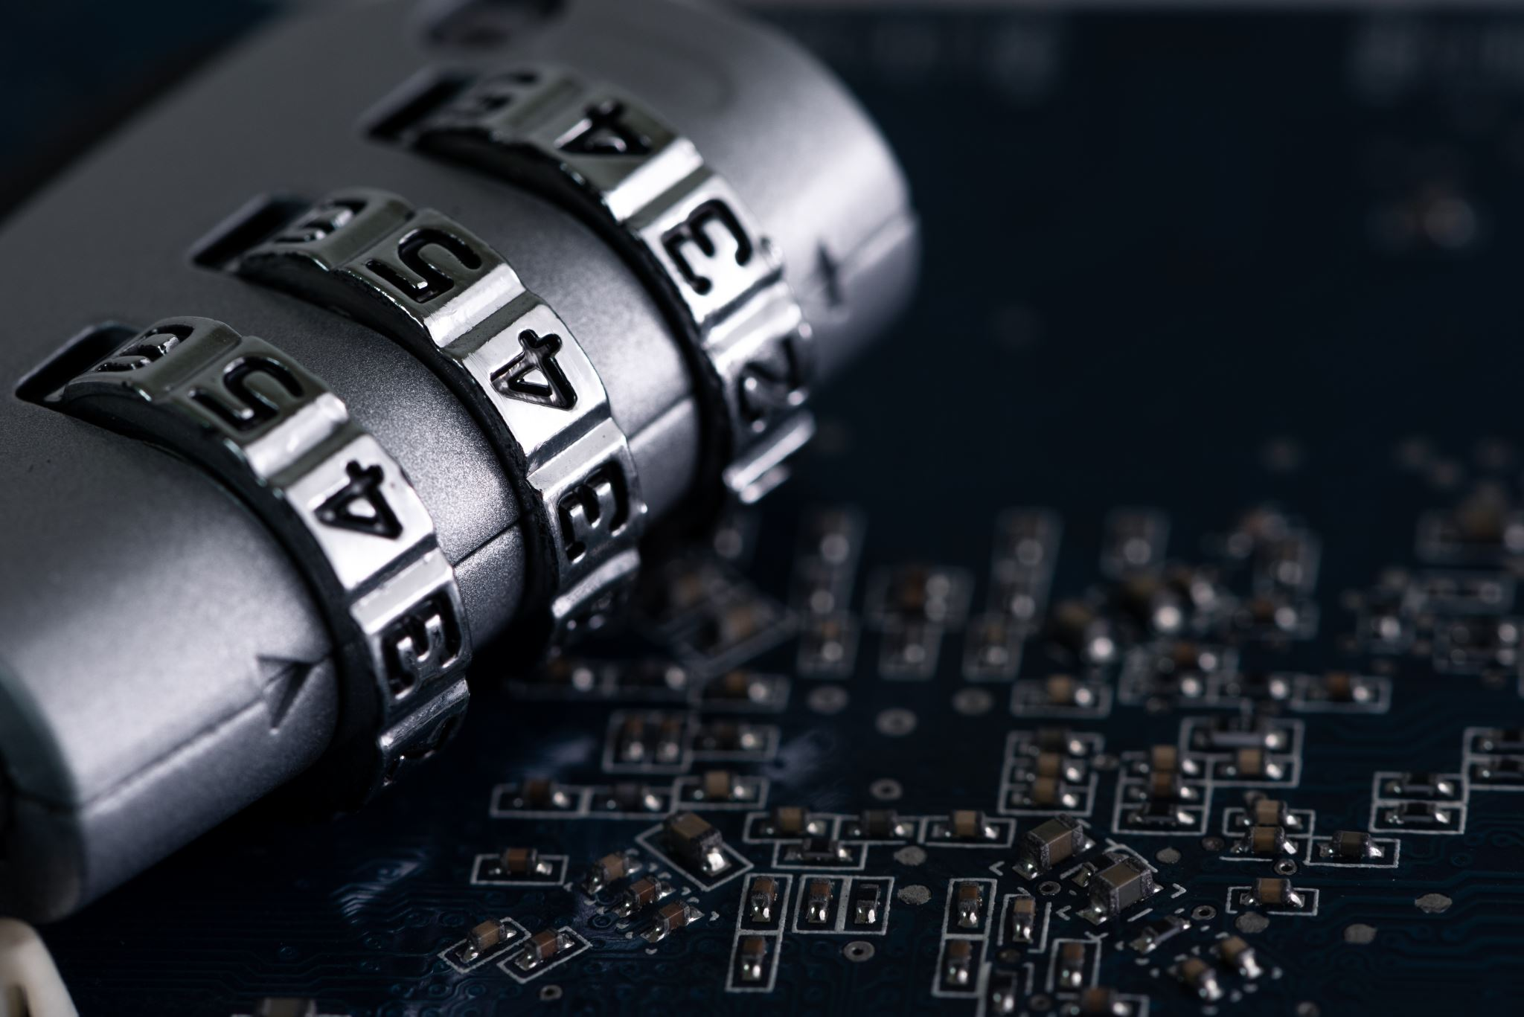

**Privacy**

Privacy, to my understanding, is the restriction or regulation that a person/group has over their personal information, to selectively express themselves to the outside world. This can come in many different shapes, sizes and flavors; ranging from our governments monitoring of what we as US citizens do in our day to day lives, to your social media restrictions that allow you to take control of who sees your posts, and even our universities method of email connection encryption(TLS). There are four main types of privacy as detailed below …

|  |  |
| --- | --- |
| 1. Bodily **privacy** (private parts) – The Privacy that you physically have from against invasive procedures such as drug testing and cavity searches. | 1. Territorial **privacy** (private places) – The Privacy that regards public spaces such as at the workplace. |
| 1. Communications **privacy** (private messages) – The Privacy that communications mediums have such as telephone, or email. | 1. Information **privacy** (Personal Info) – The Privacy that regards the collection and distribution of personally identifiable information, such as social security numbers or credit card information. |

Now that you too, have a good understanding of what Privacy is and means, please read the short article( and I mean short), “Security and Privacy Issues on Internet Social Networks”[(See Here)](https://cacm.acm.org/blogs/blog-cacm/53548-security-and-privacy-issues-on-internet-social-networks/fulltext), and pick 1 question to respond to it with something profound. If something is unclear in the directions provided, please express your question in the discussion, and I’d be more than happy to clarify.

* Have you, or a loved one ever experience the leaking of personal data that lead to the breach of an internet profile?(Hackers acquisition of one or multiple accounts, whether social media or otherwise) If yes, than please give a brief summary of what lead to the breach.
* What type of defenses have you put in place to protect your own user data?(Passwords, Phone Numbers, Locations, etc.)
* How would you rate your own privacy habits from 1-10, and explain why you’d appraise yourself this way.

NOTE: If you don’t feel comfortable providing input to the discussion on your own security practices, then please explain why you have inability to disclose the proper information.

Thank you all very much, and I will be responding frequently to discussion board posts with feedback/input in the form of questions. Take care and have a blessed Week 8!

Regards,

Ryan J. Skelly